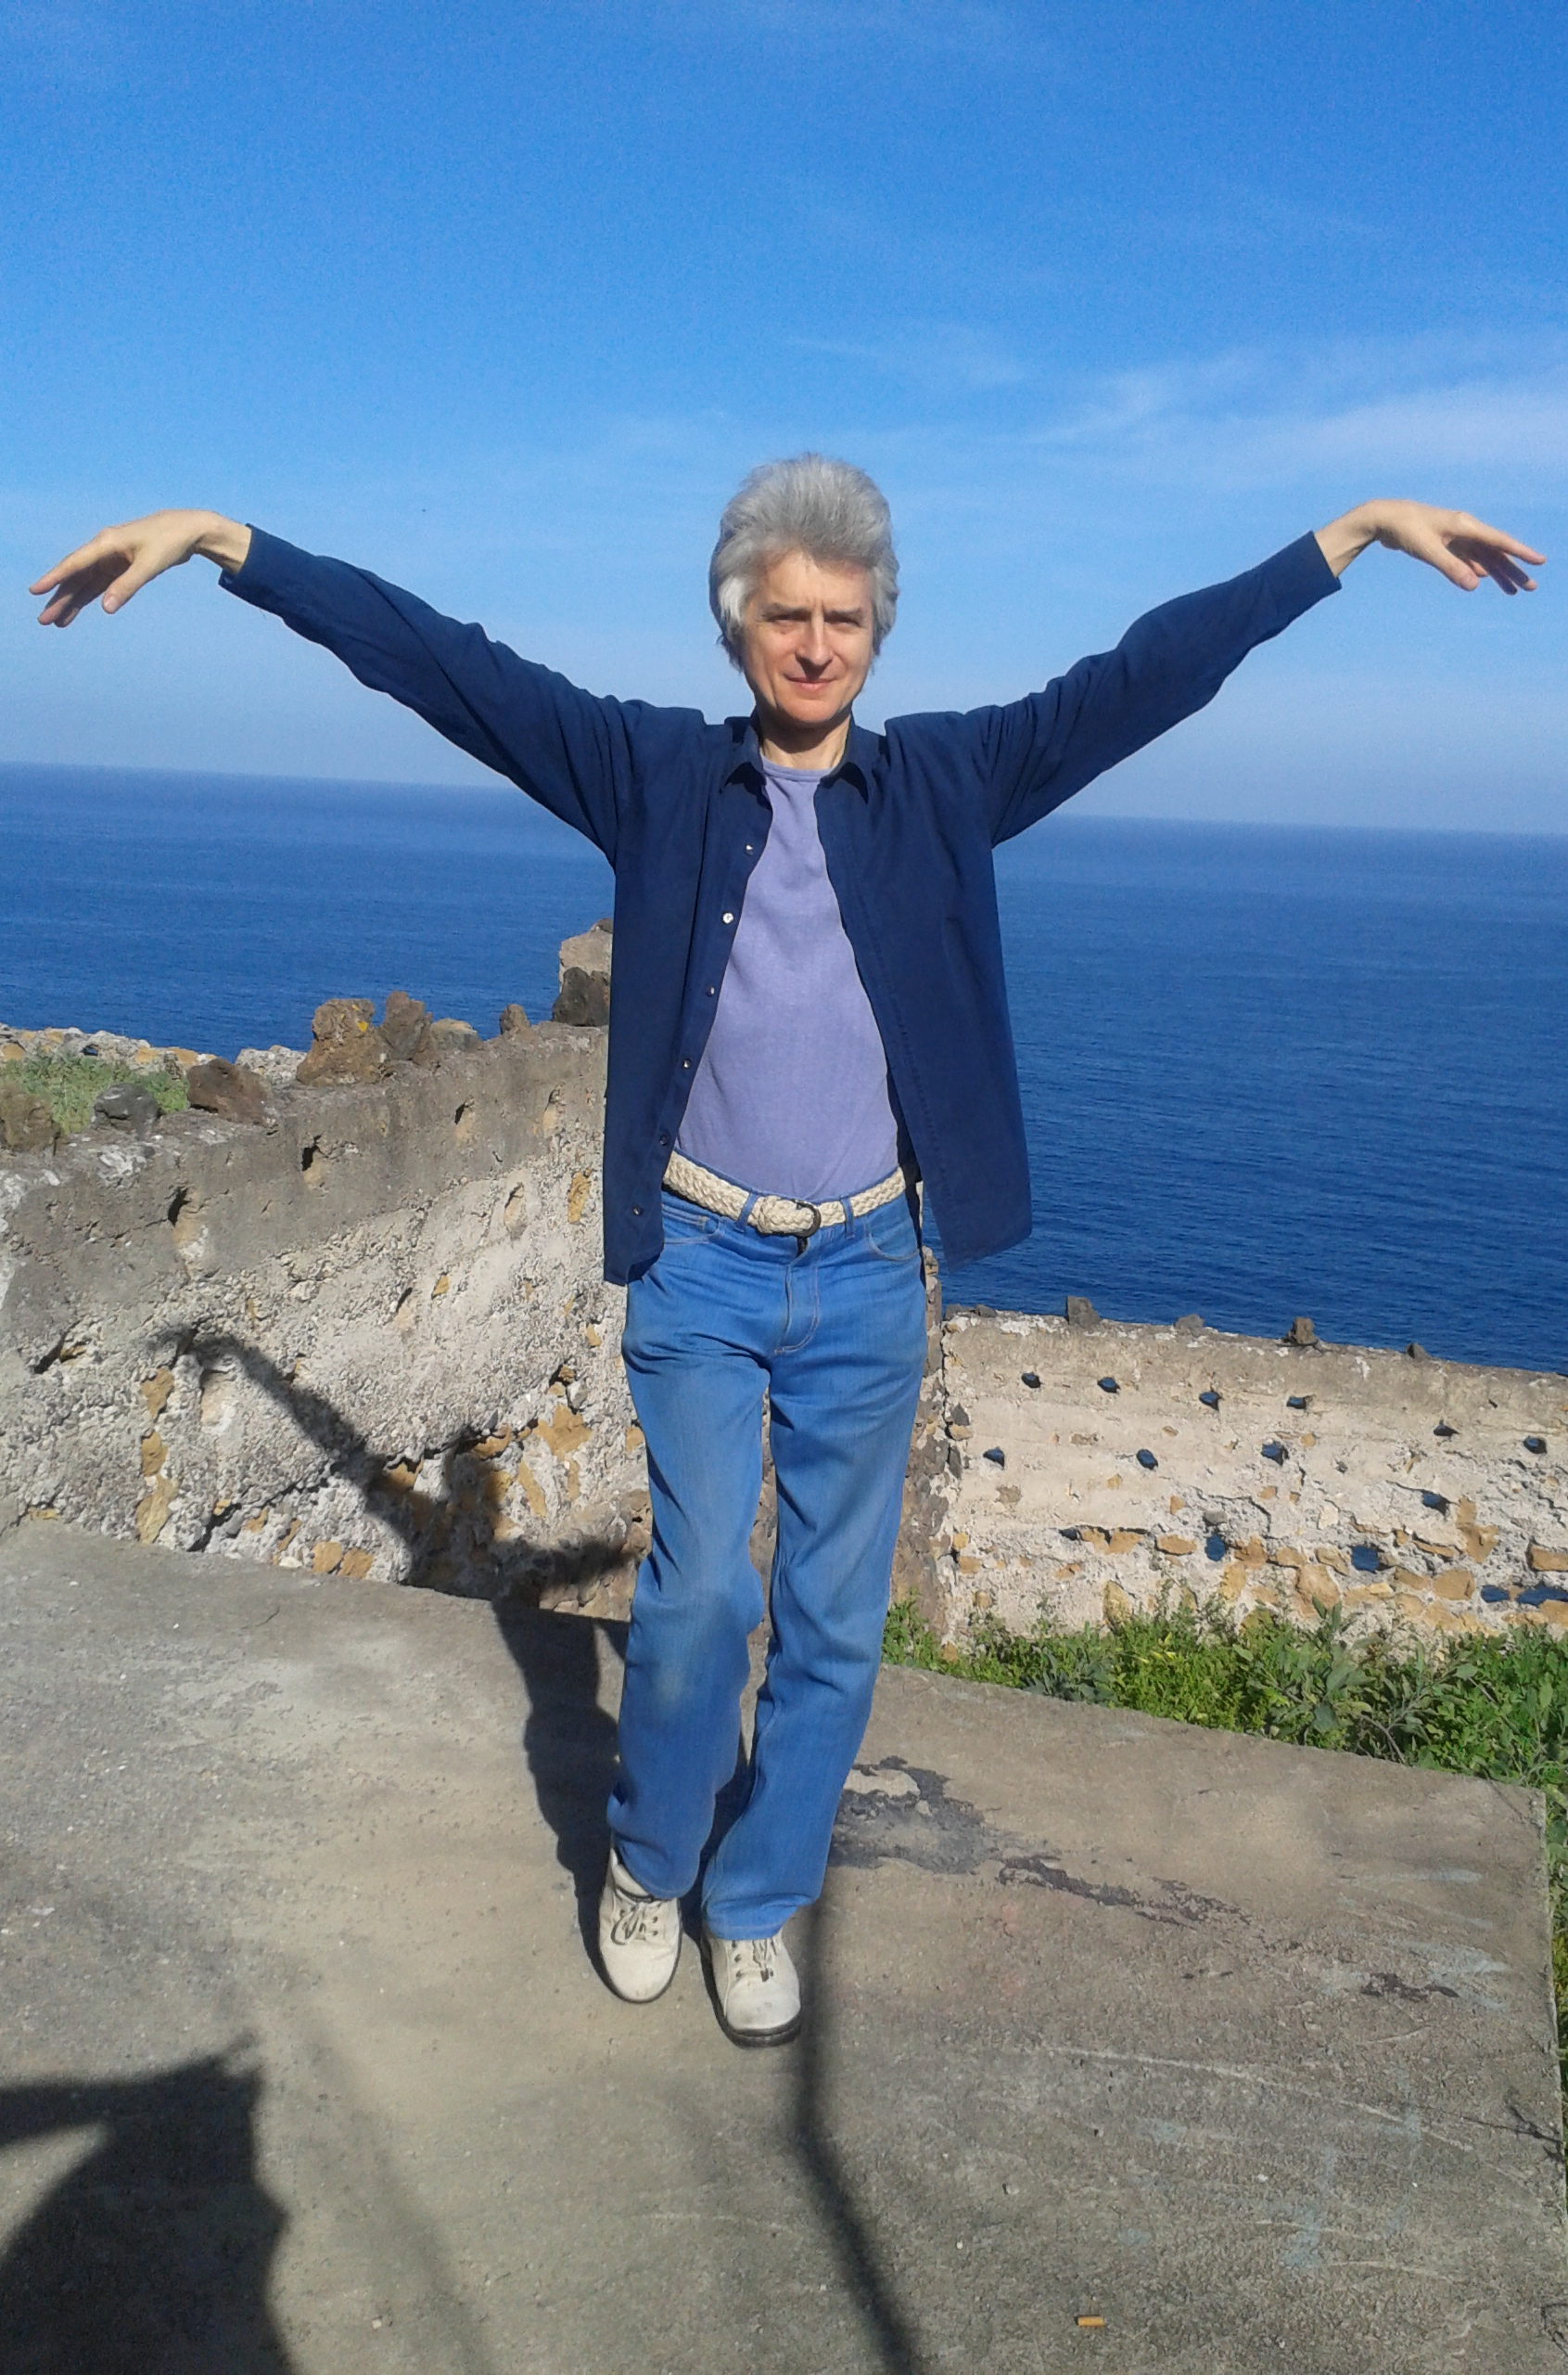
Hua Gong holiday in Tenerife 2016

Hua Gong is a unique combination of gentle movement and meditation, well known for its healing properties. Hua Gong holidays with professional trainer, Dario Gerchi, combine healing and relaxation in the warmth of Canary Islands and verdant beauty of the northern part of Tenerife.

The 5-day Hua Gong holiday 1-5th February 2016 consists of three hours of Hua Gong practice each day, with Dario's expert support through a progression of movements and meditations. Group numbers are limited and the holiday is suitable for students at all levels of practice and fitness, including complete beginners.
Also, Sunday 31st January (10.30-5pm) may be added.
And Sunday 7th February (10.30-5pm) at Hacienda Cristóforo in the South-west of the island is also available. (Both also available as half days 10.30-1.30pm.)

Sessions take place in the lovely settings of Finca Saroga, your holiday retreat. You may also choose to stay at the Hotel Marte in Puerto de la Cruz which is under the same management of Finca Saroga. The atmosphere is informal, with plenty of free time for sightseeing, relaxation and enjoying the beautiful surroundings. Social events typically include a picnic, informal evenings and local visits. This holiday is ideal for people who want to join a residential Hua Gong workshop with a small group in a beautiful, warm place in the middle of Winter. You can also extend your stay for a longer break and join extra Hua Gong sessions by arrangement.
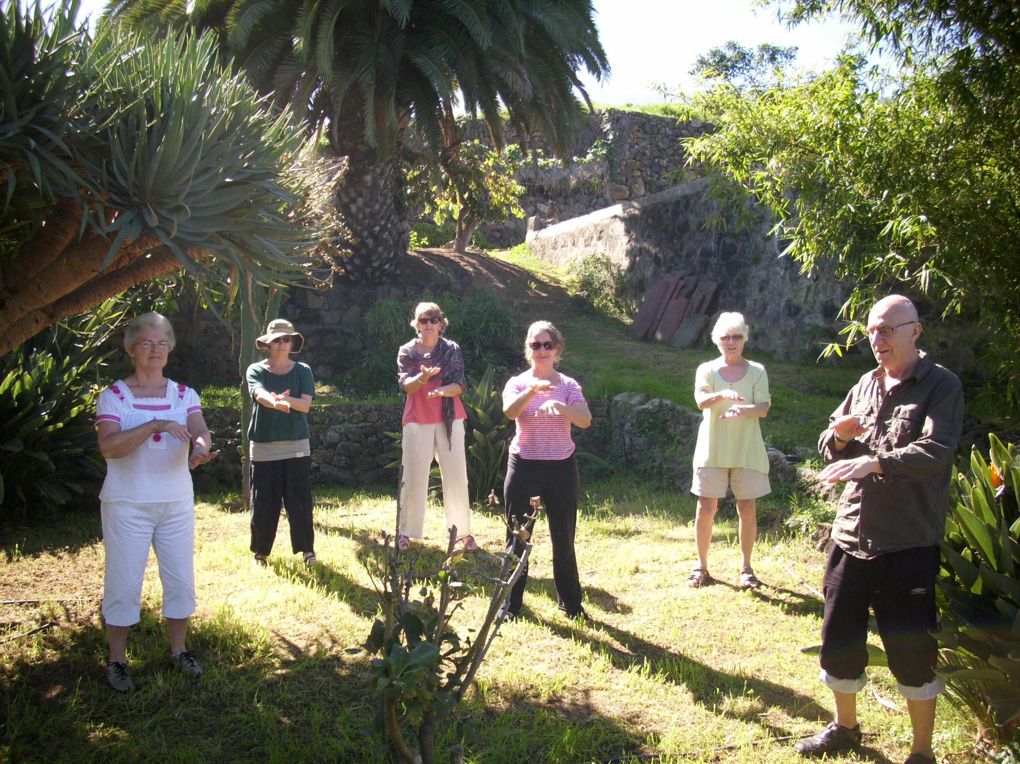
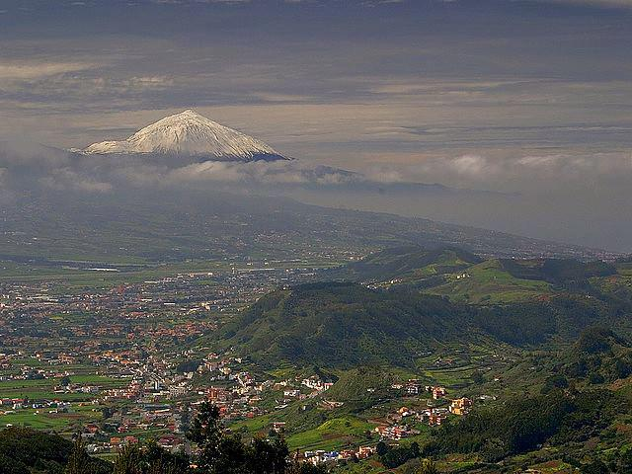
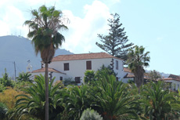Finca Saroga^ El Teide (3718m) ->
Finca Saroga is a beautifully renovated traditional 17th century farmhouse set in the Orotava Valley just outside Puerto de la Cruz, with simply furnished self catering apartments, surrounded by gardens with fruit trees and medicinal plants and ponds.
From under £45 a day per person (tuition and accommodation in self catering apartments) - see over for dates and booking information. Special earlybird and other discounts available.
Holiday dates and costs
Holiday dates 2016 | Tuition costs  £ | Accom per person per night £* |  | For £15 Earlybird discount book by
Holiday dates 2016 | Tuition costs  £ | shared room | single room | For £15 Earlybird discount book by
31 Jan (full/half day) | 40/25 | 17-21 | 41 | n/a
1-5 Feb | 120 | 17-21 | 41 | - 11th January 2016
7 Feb** (full/half day) | 40/25 | 25-29 | 41 | **at Hacienda Cristóforo  (see separate brochure)
*at exchange rate £1=€1.2
This is can be a self catering holiday, so you can take advantage of fresh, local produce (including local organic vegetables) to prepare your own meals. Accommodation costs include bedding and towels. Alternatively you can stay at the Hotel Marte or we can help you find other accommodation.

Special discounts
Book now for a £15 Earlybird discount. Bring a friend for £5 discount each.
Book the week plus Sunday 19th or Sunday 26th for just £150 (£135 Earlybird.) Or week plus both extra days for £180 (£165 Earlybird.) Or week plus half day Sunday £140 (£125 Earlybird.) Flexible arrangements for longer stays and extra tuition, please ask.

Getting there
Book your own travel in advance to arrive by plane to Tenerife North or South airports.
Regular low cost flights by Ryanair, Easyjet, plus Monarch, Vueling or Air Europa.
Helpful information available. Ask Dario.

Local Airports  Tenerife North Los Rodeos (TFN) (25 mins)  Tenerife South Reina Sofia (TFS) (55 mins) | Flexible booking dates to help with cheaper flights. Bus service available from both airports to Puerto de la Cruz (walking distance to Hotel Marte or a 12 minute drive to Finca Saroga.)  Car hire optional but very useful. (Have a look at www.doyouspain.com)
How to book
First contact Dario who will help you with all aspects of your holiday. Then book your accommodation directly with Finca Saroga/Hotel Marte. Book early – limited availability!!
Hua Gong sessions & general information | Accommodation and local information
Contact Dario on +44 (0)20 8768 5683;  (mobile) +44 (0)7932 565994  E-mail: dario@gn.apc.org  Website: www.qigongdario.com | Contact Finca Saroga/Hotel Marte:  (+34) 922 384352  www.fincasaroga.es www.hotel-marte.com

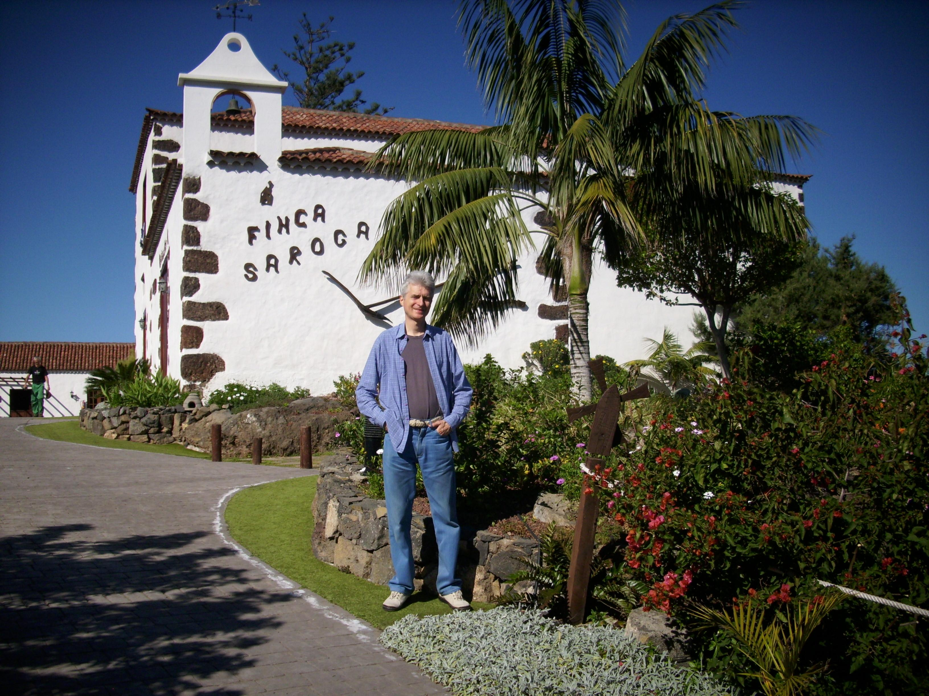
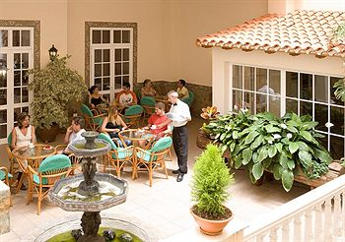Hotel Marte
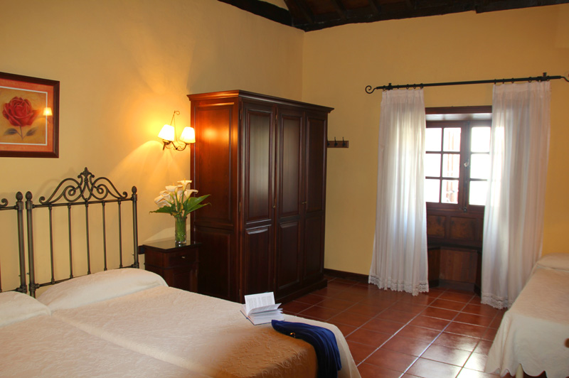Finca Saroga

